Periodical Capitalization and Revenue Recognition Project screen Additional Functionality – CRIM 0512

|  |  |  |  |  |
| --- | --- | --- | --- | --- |
| **Ver** | **Date** | **Author** | **Comments** | **Reviewed by** |
| 1 | 22/01/2021 | Tom Bell | CRIM 0512 | TBC |
|  |  |  |  |  |

Requirements 2

Prerequisites 2

Solution Overview 2

Solution Details 2

Security 3

Companies 3

Data Migration 3

Test Steps 3

Technical Implementation 3

Requirements

The Periodical Capitalisation and Revenue Recognition Project screen needs additional columns and extra RMB options.

Prerequisites

N/A

Solution Overview

The Period Capitalisation and Revenue Recognition Project period screen needs extra functionality and columns. These include:

* RMB option to Finance Project
* RMB option to Project Navigator
* RMB option to Project
* Additional Columns:
  + Customer ID
  + Customer Name
  + Main Representative
  + Sales Contract
  + Region
  + Category 1
  + Category 2
  + Program
  + Project Status
  + Actual Start Date
  + Planned Start Date
  + Actual Finish Date
  + Planned Finish Date

Solution Details

From the Periodical Capitalisation and Revenue Recognition screen a user will RMB a period and select Periodical Capitalisation and Revenue Recognition Project.

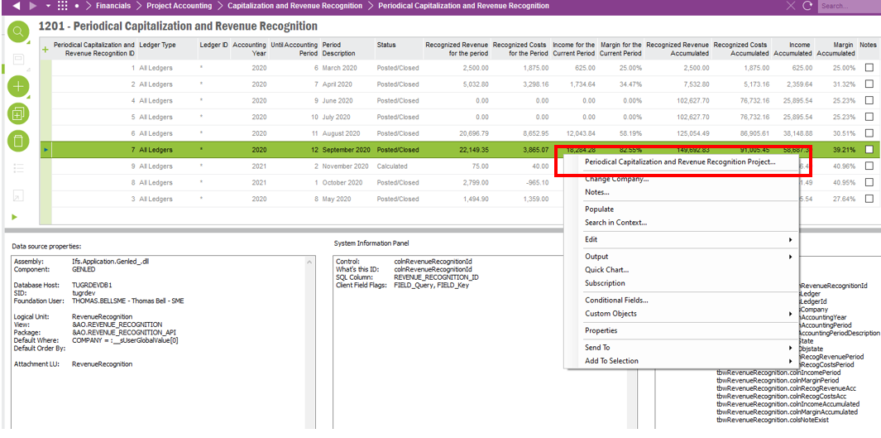

The user is then brought the Periodical Capitalisation and Revenue Recognition Project screen. It is in this screen where additional columns and extra functionality are required.

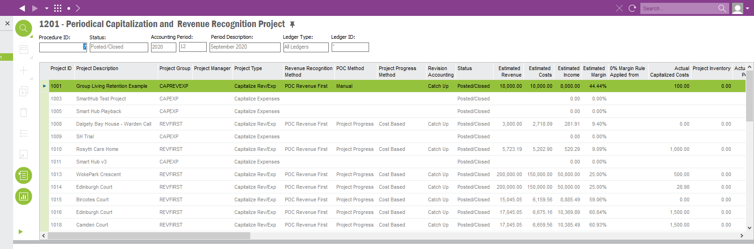

Additional RMB Options

The following RMB options from the Periodical Capitalisation and Revenue Recognition Project screen must be available when RMB on a line.

* **Finance Project RMB** - Financials > Project Accounting > Project screen
* **Project Navigator** **RMB** - Project Management > Plan and Execute > Project Navigator screen
* **Project RMB**– Project Management > Plan and Execute > Project screen

Finance Project RMB option

RMB option from the Periodical Capitalisation and Revenue Recognition Project screen is required called “Finance Project”. By clicking onto this option, the user will be brought the Project screen.

**NOTE: Currently, there is an RMB option called “Project…” (see red box below) that takes the user to the Project Finance screen. This RMB option can simply be renamed “Finance Project” to save development time.**

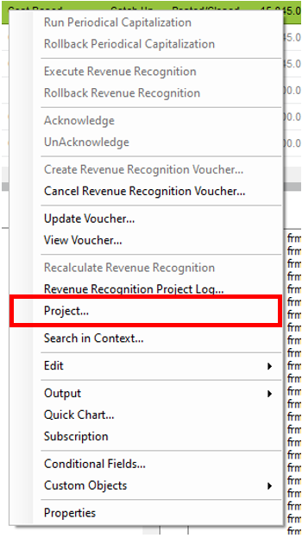

An RMB on a line and selecting “Finance Project” needs to bring the user to the Project screen for the Project ID of the line that weas RMB’d, this is shown on the below screenshot.

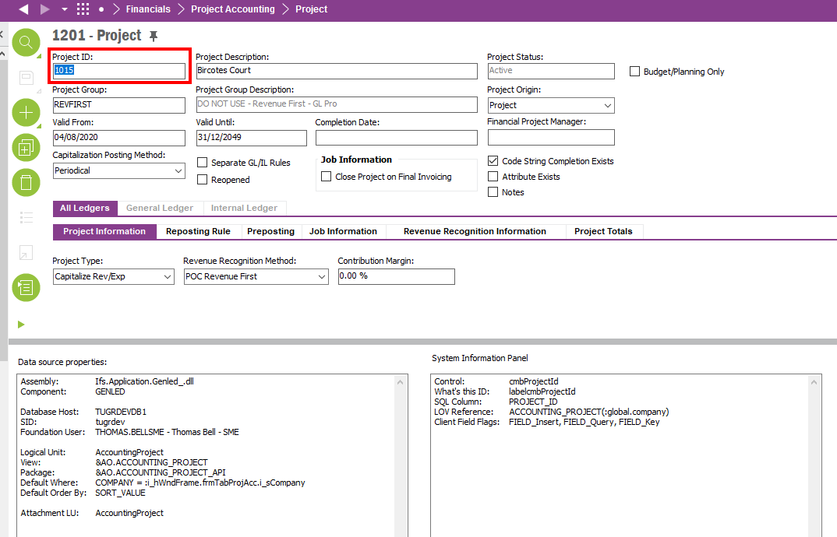

Project Navigator RMB option

An RMB on a line from the Periodical Capitalisation and Revenue Recognition Project screen a “Project Navigator” option must be available. Clicking on the Project Navigator RMB takes the user to the Project Navigator screen of the Project ID that was RMB’d.

The below option shows an RMB for Project 1015. In this RMB the Project Navigator option must be available and must go to the project Navigator screen for Project ID 1015..

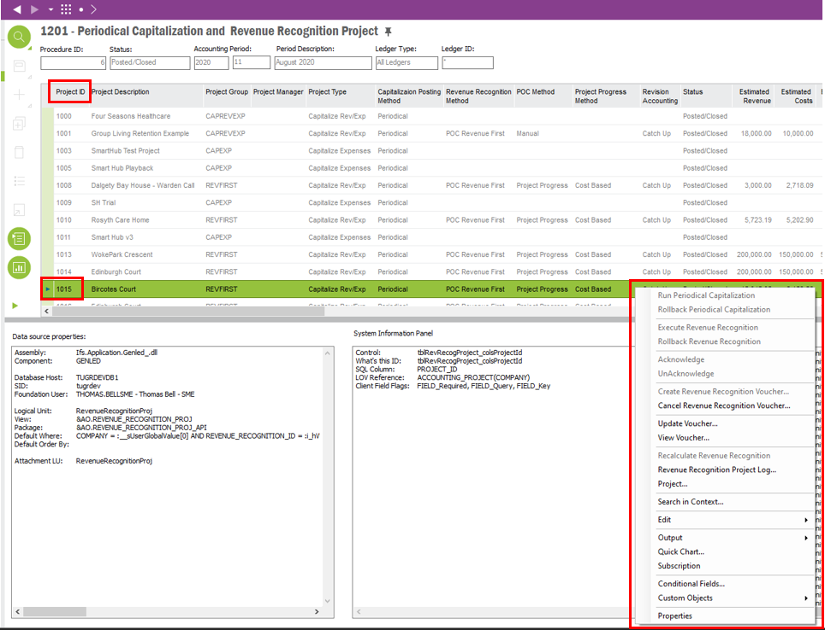

The below screenshot shows the Project Navigator for Project 1015 as this is the project that was RMB’d on the previous screen.

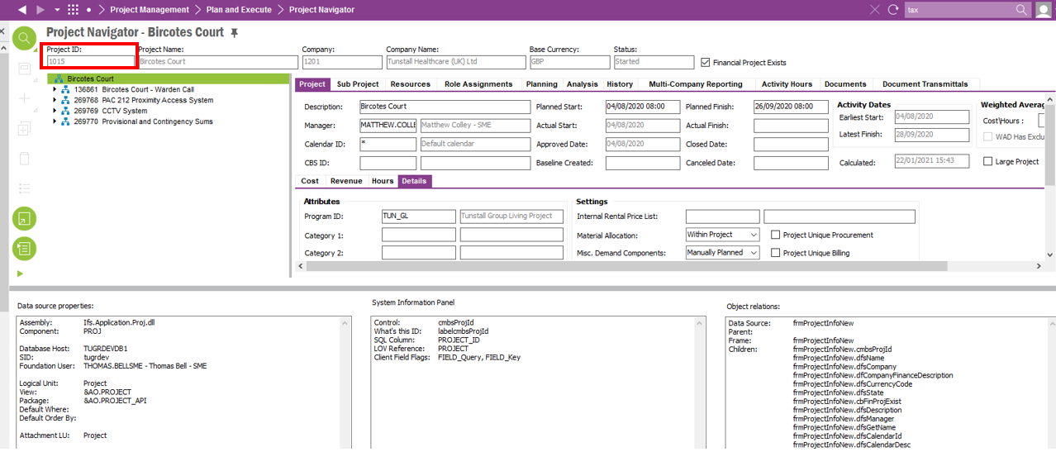

Project RMB Option

An RMB on a line from the Periodical Capitalisation and Revenue Recognition Project screen a “Project” option must be available. By clicking on the Project option this should take the user to the Project screen of the Project ID that was RMB’d.

The below option shows an RMB for Project 1015. In this RMB the “Project” option must be available and navigate the user to the screen as shown below for the appropriate Project ID of the line that was RMB’d.

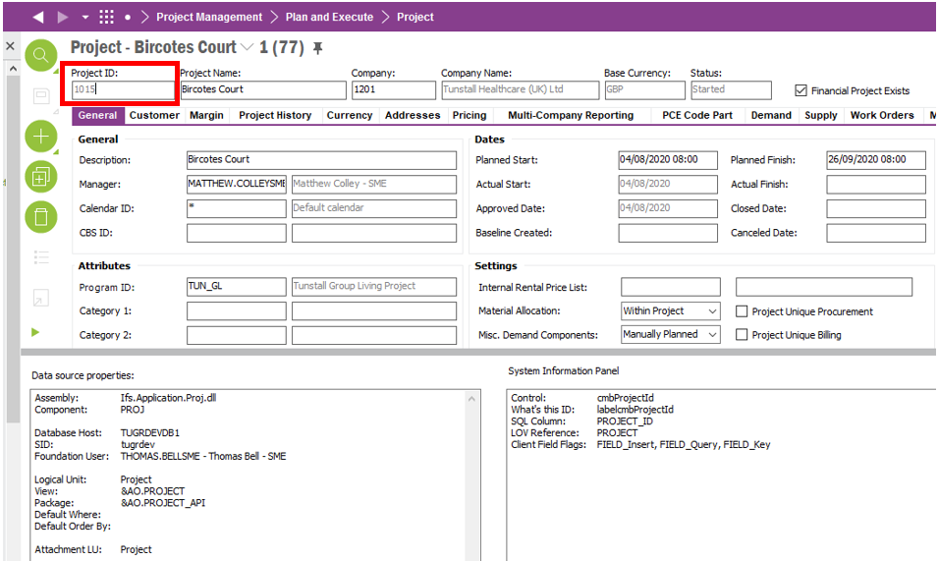

Extra Columns Required

The below section will detail the extras columns that are required in the Periodical Capitalisation and Revenue Recognition Project Period screen. All of these columns are required in the screen as shown in the screenshot below.

The extra columns need to show data relevant to that line. The Project ID will be used to determine the data in each column.

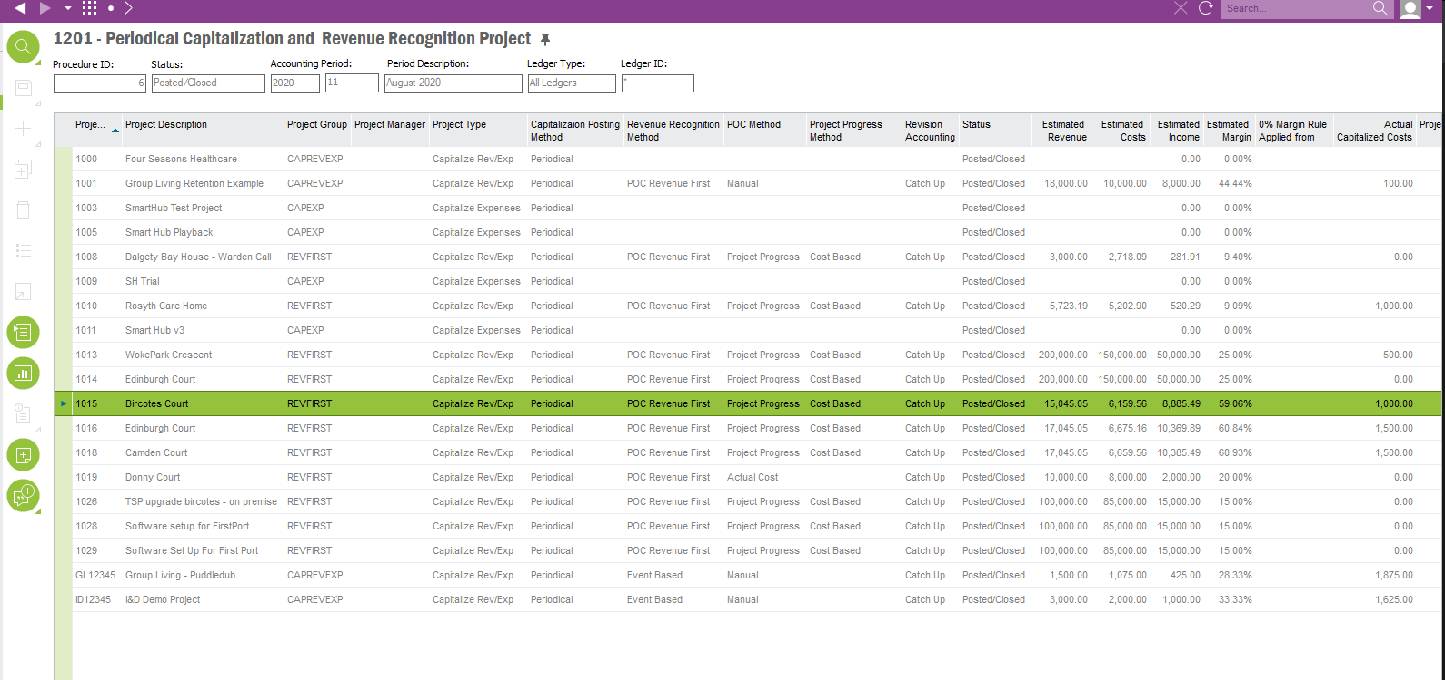

Customer ID Column

A column is needed called “Customer ID” in the Periodical Capitalisation and Revenue Recognition Project screen. The column will show the Customer Name for the particular Project ID. The Customer ID data can be found on the Customer tab within the Project screen.

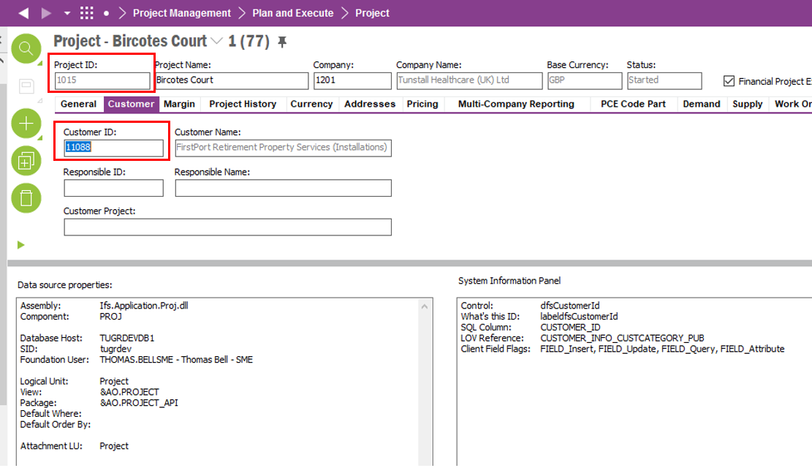

Customer Name Column

A column called “Customer Name” is needed in the Periodical Capitalisation and Revenue Recognition Project screen. The column will show the Customer Name for the particular Project ID. The Customer Name data can be found on the Customer tab within the Project screen.

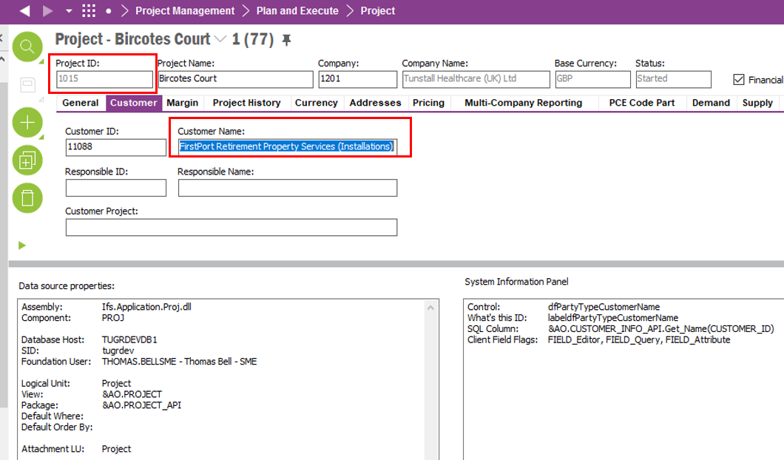

Main Representative Column

A column is needed to show the Main Representative of the Customer for that particular project. The data is linked to the Periodical Capitalisation and Revenue Recognition Project screen by Project ID > Customer ID > Main Representative.

The below screenshots show how the Main Representative and the Project ID are linked and where the data is found. The Project screen and Customer screens are used.

The below screenshot shows the Project ID for the Main Representative that we’re wanting to display in this column.

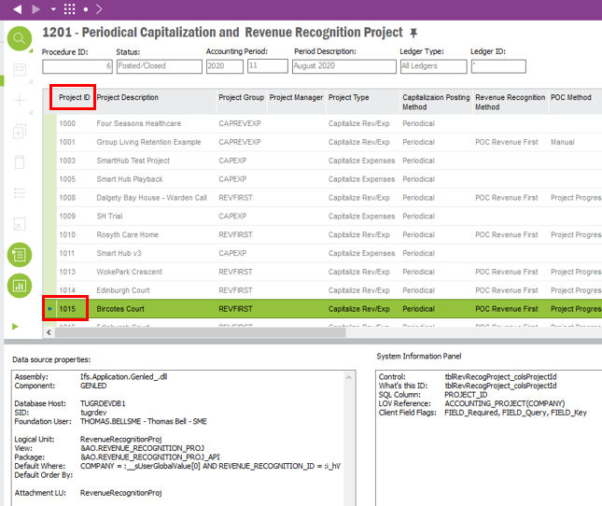

The below screenshot shows the Project screen that also shows the Customer ID is on the Customer Tab. From the Customer ID we can now find the Main Representative.

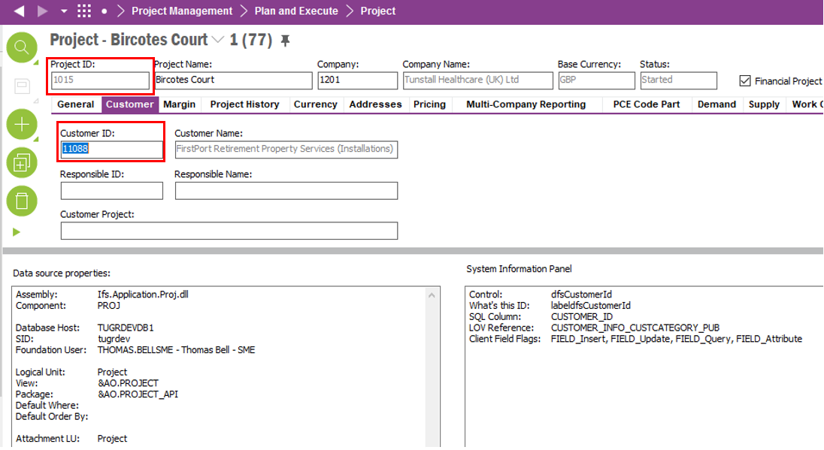

Using the Customer ID from the screenshot above the Main Representative field can be located from the Customer Screen, CRM Info tab,. General Tab. This field must be displayed in column “Main Representative” in the Periodical Capitalisation and Revenue Recognition Project screen.

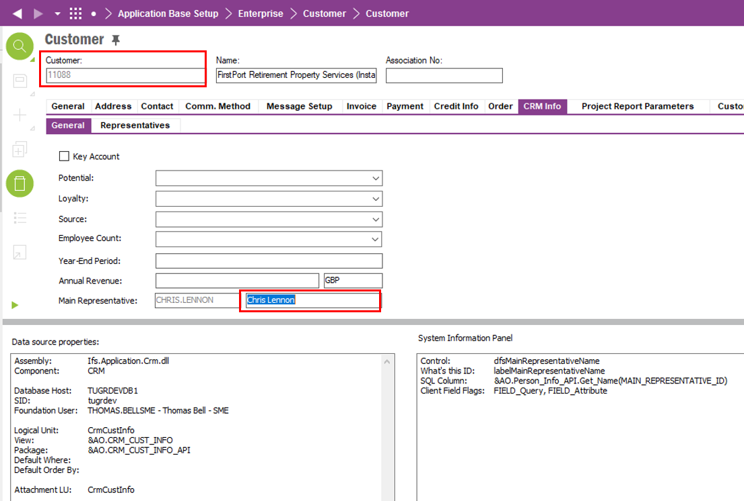

Sales Contract No. Column

A column is needed called “Sales Contract No.” in the Periodical Capitalisation and Revenue Recognition Project screen. This column will show the Sales Contract Number of the Project.

The below screenshot shows the Service Contract that this Project ID is attached to.

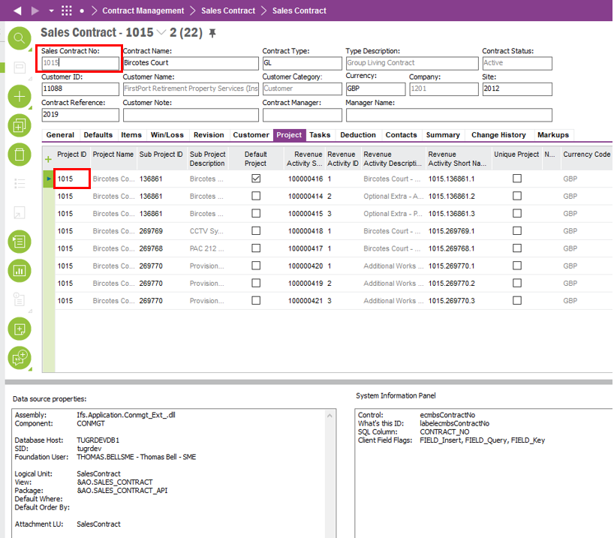

Region Description

A Region Description column is needed called “Region” in the Periodical Capitalisation and Revenue Recognition Project screen.. The data is located on the Sales Contract that the Project is attached to as per above.

The below screenshot shows where the Region Description data can be located.

Project ID > Sales Contract No > Region Description

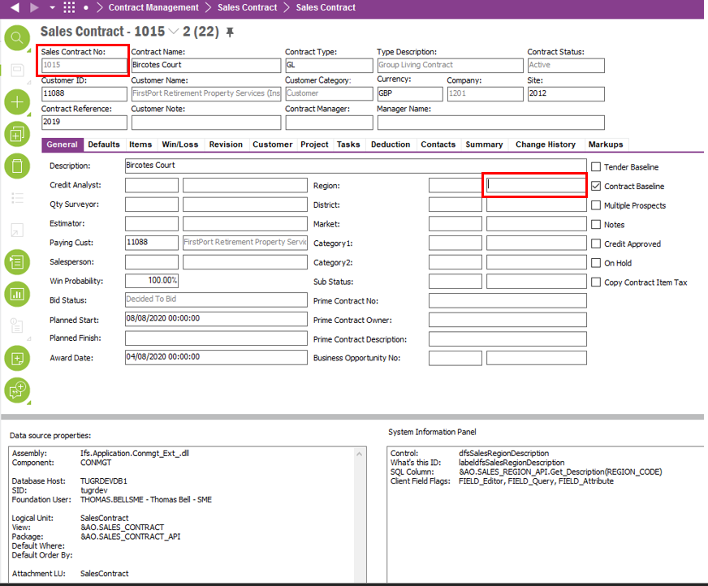

Category 1 Column

A column called Category 1 is needed. This column will display the Category 1 Description for that Project ID in the Periodical Capitalisation and Revenue Recognition Project screen..

The below screenshot shows the Category 1 Description field that needs to be populated in this column.

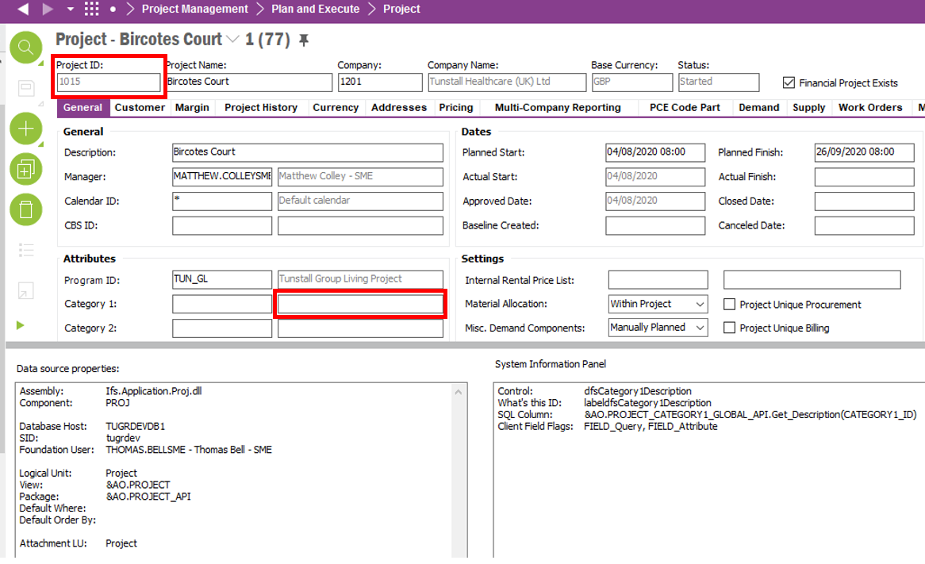

Category 2 Column

A column called Category 2 is needed. This column will display the Category 2 Description for that Project ID in the Periodical Capitalisation and Revenue Recognition Project screen..

The below screenshot shows the Category 2 Description field that needs to be populated in this column.

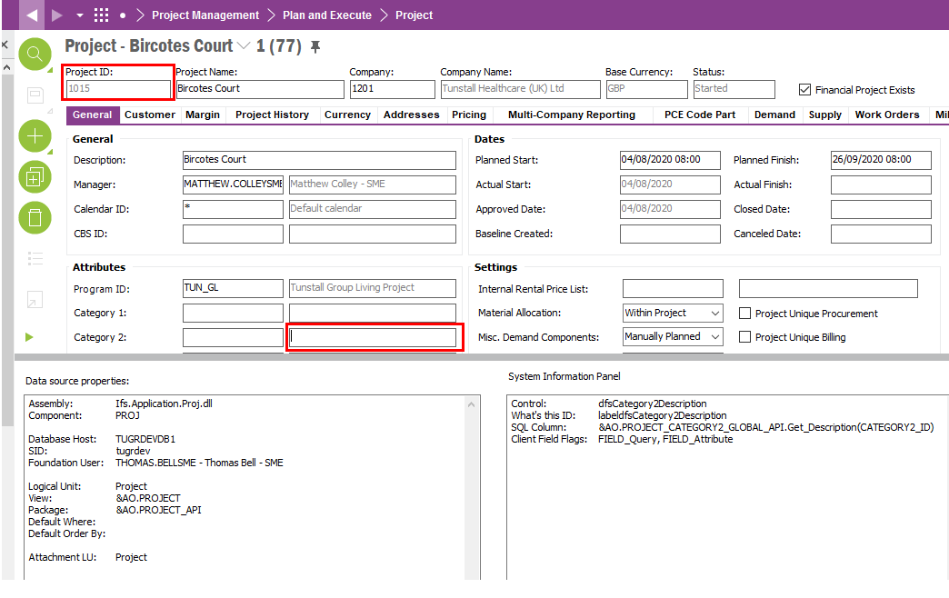

Program ID Column

A column called “Program” is needed that shows the Program Description for the Project ID in that line.

The below screenshot shows the Program Description field on the project from the Project Screen. This data is required in the called “Program” in the Periodical Capitalisation and Revenue Recognition Project screen.

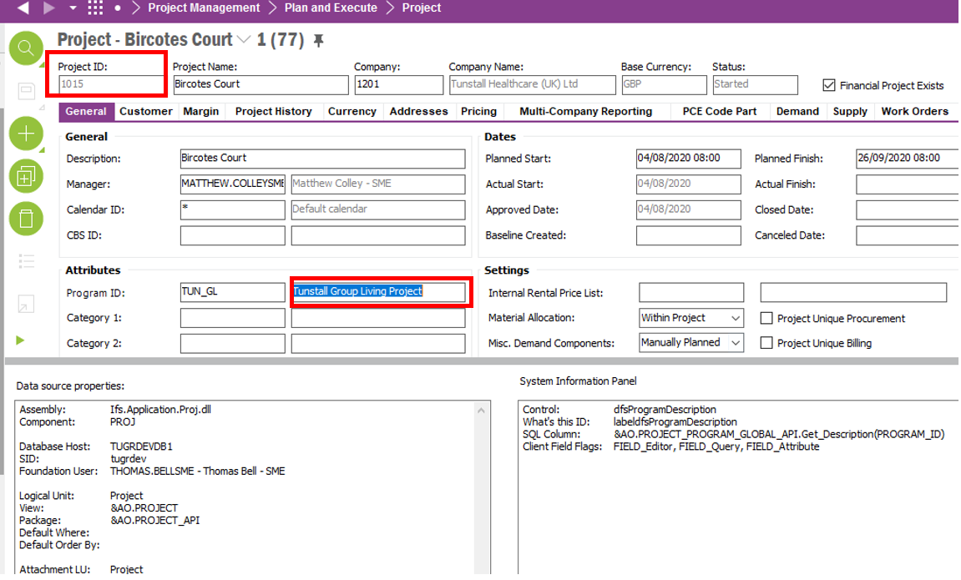

Project Status Column

A column called Project Status is needed that shows the status of the project for the Project ID in that line.

The below screenshot shows the “Project Status” on the project. This data is required in the column called “Project Status” in the Periodical Capitalisation and Revenue Recognition Project screen.

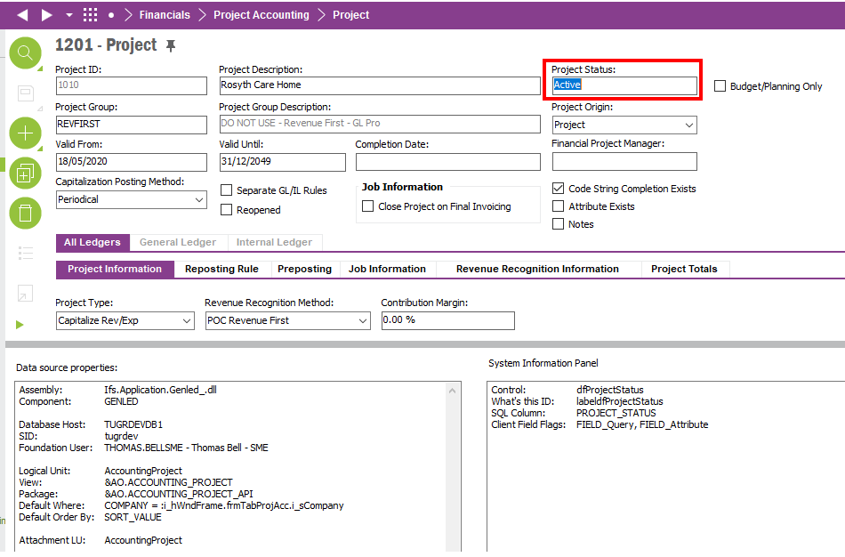

Actual Start Date Column

A column called Actual Start is required that shows the Actual Start Date of the Project in the Periodical Capitalisation and Revenue Recognition Project screen. The below screenshot shows where the Actual Start Date data is located.

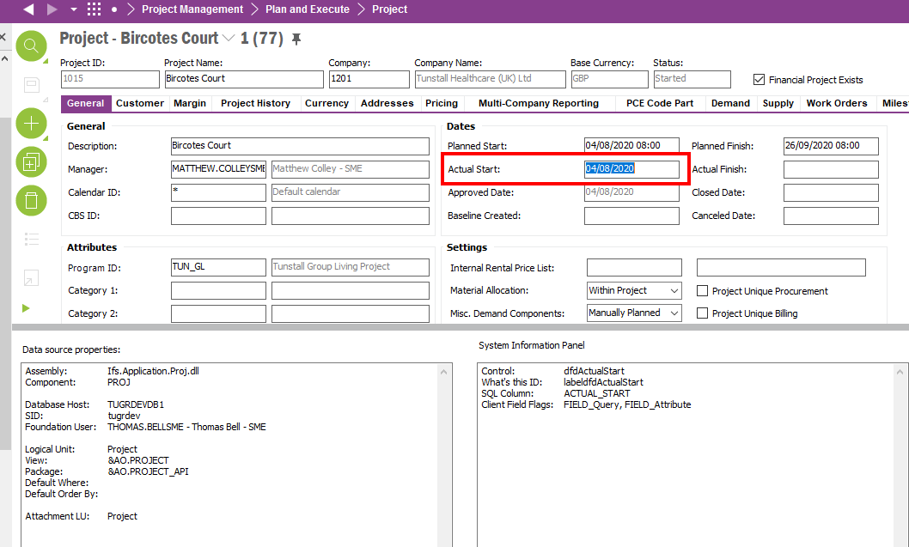

Planned Start Date Column

A column called Planned Start is required that shows the Actual Start Date of the Project in DD/MM/YYYY format in the Periodical Capitalisation and Revenue Recognition Project screen. The below screenshot shows where the Planned Start Date data is located.

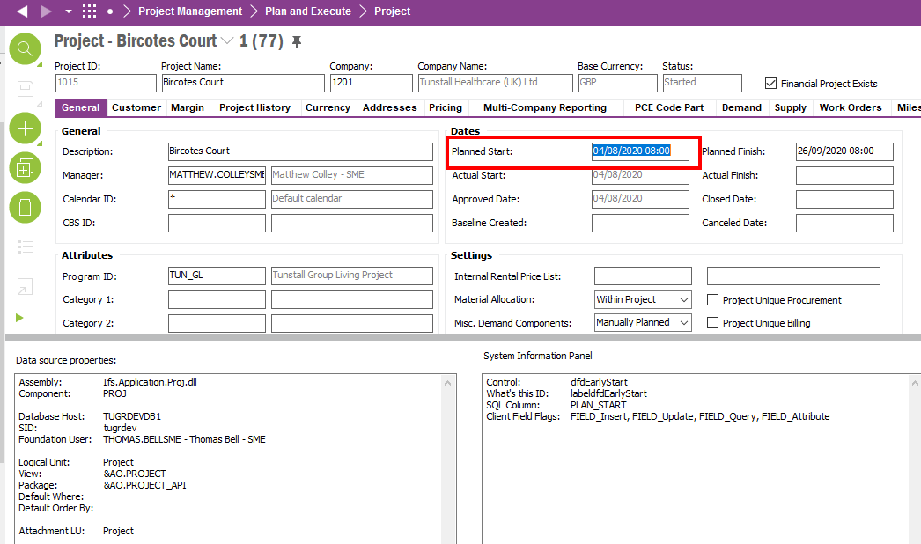

Actual Finish Date Column

A column called Actual Finish Date is required that shows the Actual Finish Date of the Project in DD/MM/YYYY format in the Periodical Capitalisation and Revenue Recognition Project screen. The below screenshot shows where the Actual Finish Date data is located.

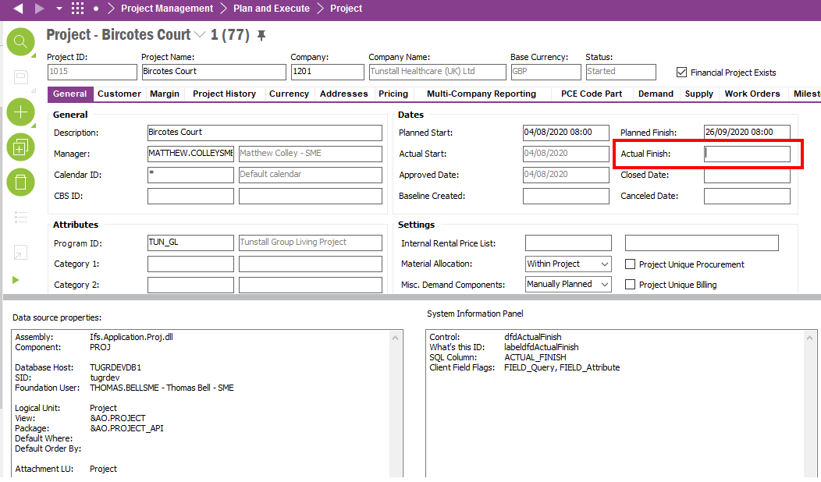

Planned Finish Date Column

A column called Planned Finish Date is required that shows the Planned Finish Date of the Project in DD/MM/YYYY format in the Periodical Capitalisation and Revenue Recognition Project screen. The below screenshot shows where the Planned Finish Date data is located.

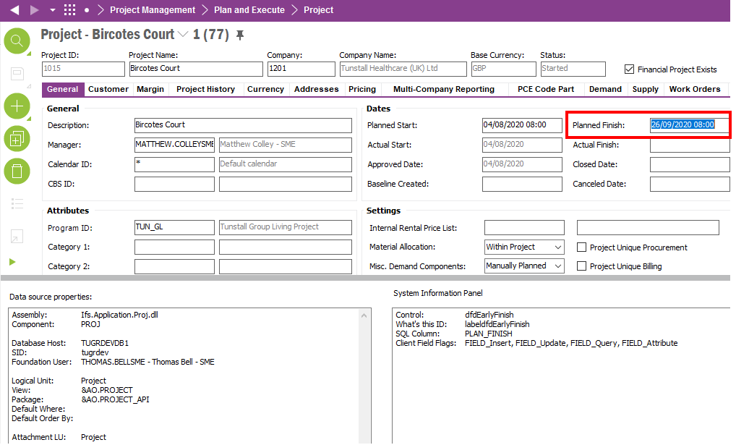

Technical.

Field Definitions.

<New Field/CLU Definition>

|  |  |  |  |  |  |  |
| --- | --- | --- | --- | --- | --- | --- |
| New DB Object Name | DB Object Item/Field Names | Item Description | Item Data Type | Item Syntax | Calculation Spec, if Derived | LOVs/Enums/Is Mandatory? |
|  |  |  |  |  |  |  |
|  |  |  |  |  |  |  |
|  |  |  |  |  |  |  |
|  |  |  |  |  |  |  |
|  |  |  |  |  |  |  |
|  |  |  |  |  |  |  |
|  |  |  |  |  |  |  |
|  |  |  |  |  |  |  |
|  |  |  |  |  |  |  |
|  |  |  |  |  |  |  |
|  |  |  |  |  |  |  |
|  |  |  |  |  |  |  |

Security

<Define security controls> (Who needs access to this and will it be restricted from any other users etc)

Companies

Applies to the following companies. All.

|  |  |
| --- | --- |
| **Company** | **Required (Y/N)** |
| 1201 | Y |
| TBC |  |
|  |  |

Data Migration

<Describe any data migration impacts this development may have – i.e additional data to be migrated>

Test Steps

<Steps that needs to be taken to test this change. Please provide expected results> Updated post solution.

|  |  |  |
| --- | --- | --- |
| **No** | **Script\Test Steps** | **Expected Result** |
| 1 | RMB line and select Project | Navigate to Project screen for the Project ID of the line that was selected. |
| 2 | RMB line and select Project Finance | Navigate to Project screen (Finance) for the Project ID of the line that was selected. |
| 3 | RMB line and select Project Navigator | Navigate to Project Navigator screen for the Project ID of the line that was selected. |
| 4 | Navigate to Periodical Capitalization and Revenue Recognition Project screen | See all 13 extra columns as described above. |

Technical Implementation

<Completed by the technical developer - Technical solution, list packages, functions, Custom menus created etc >

**Package**

EA_FINANCE

**Permissions**  
  
All objects are granted to IFS_ALL permission set.

**Custom RMB**

**Custom Fields**

**Note: - If the custom fields are not available, make sure the logical unit is published and synchronized with the fields published and approved as follows. Then reload the Periodical Capitalization and Revenue Recognition Project window and add the custom fields column using the column chooser.**

The columns needs to be added to layout via RMB, Column Chooser, Select Column.

